Riphah International University Of Lahore

Name:
Hanzla Ahmad

SAP ID:
61002

Subject:
Computer Organization and Assembly Language

Submitted to:
Mrs. Amna Bibi
Lab 2
Task 1
Take any integer as input, if the number is greater than 5 print it
_{If a>5, print a}
_{Else if a=0, than halt}
_{Else if a<5 , then halt}

Source Code:
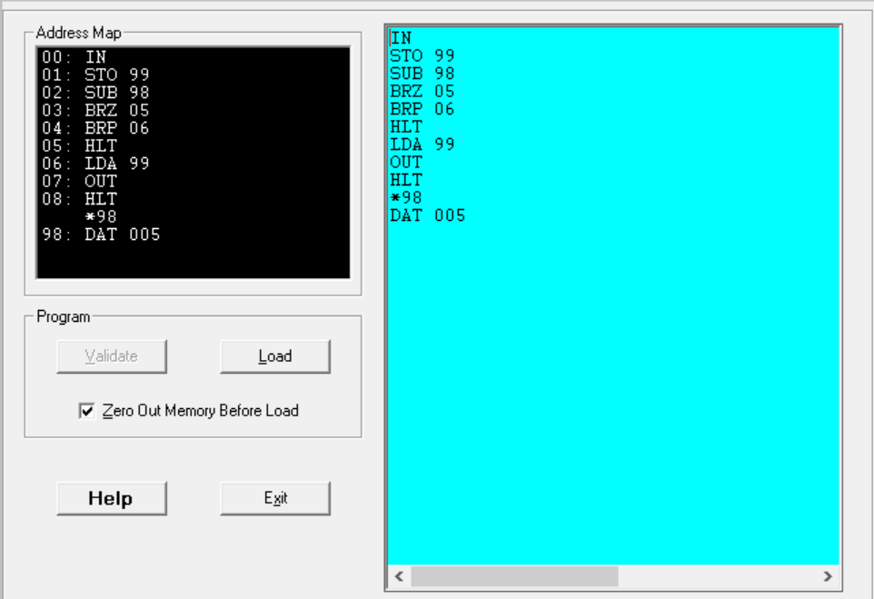

Output:
If input is 0 then halt
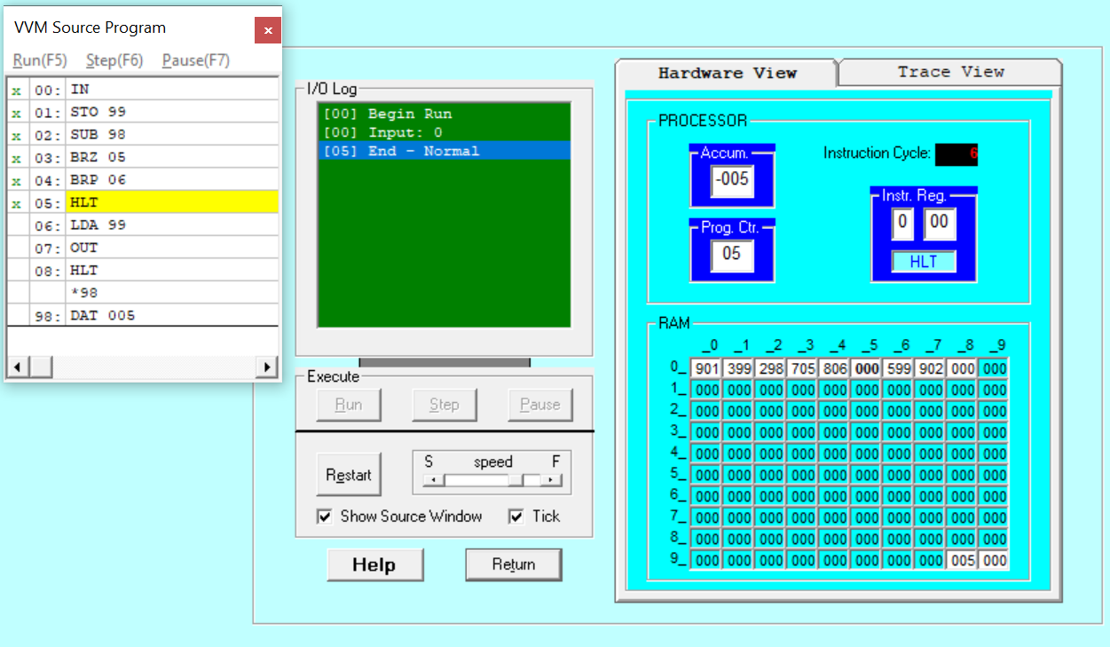
If input is 8 then print 8
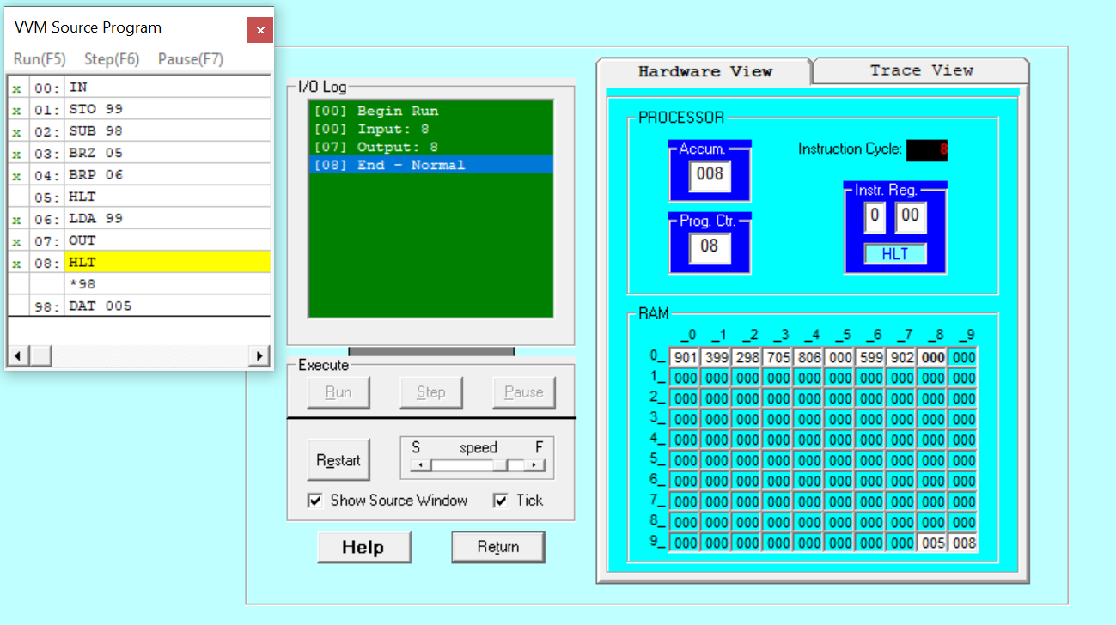
If input is 2 then halt
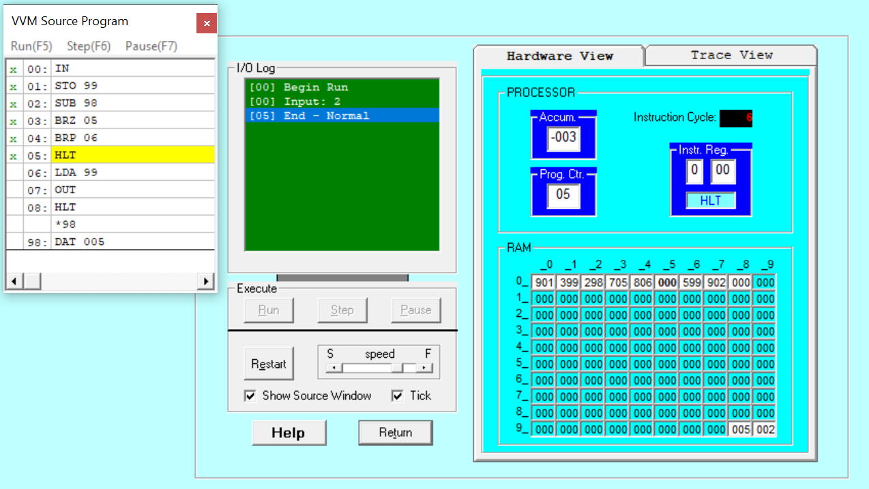

Explanation:
In this we first take a number as input after that I store it in the address 99 and then i store a value of subtraction in 98 which is 005 after that I check if input is 0 through BRZ if input is 0 then it will go to step five which leads to halt after if it is not zero then it will proceed to next step which is BRP if it is a positive number then it proceed to step 6 which is loading value from address 99 and then a printing it and then answer the program or if in BRB step there is not a positive number then it goes to its next step and ends the program. On running program if we take input zero then it will and it through BRZ but if we take input greater than 5 which is 8 then it will output the input which is 8 and if we take input smaller than 5 which is to then it will also ends the program.
Task 2

Source Code:
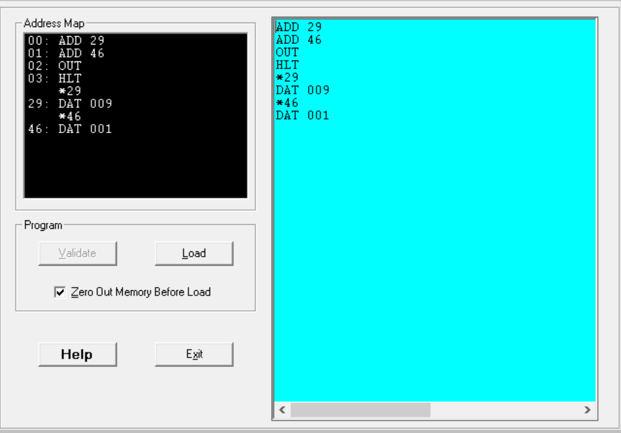

Output:
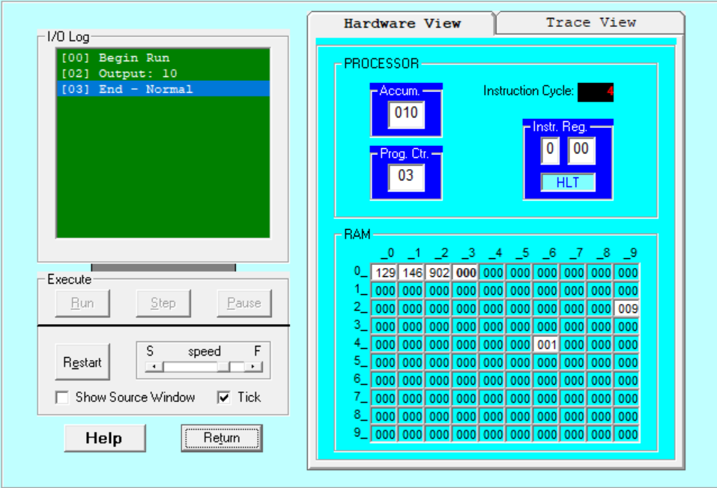

Explanation:
First, we take 2 numbers 29 and 46 hardcoded at address 29 and 46 with values 009 and 001 that will be added and we’ll print it out and the output is 10 and after that program will end.

